PLAYER & TEAM OFFICIAL
ACCREDITATION FORM

PETRONAS MALAYSIA INTERNATIONAL SERIES 2026

Please complete and return this form to perakba25@yahoo.com not later than Tuesday, 11th August 2026. Please fill up the form and send Photo as per requirement. Please take note that we will not accept Selfie Photo. Please refer to Photo sample below.

Please type clearly in CAPITAL LETTERS.

Name of Member Association:
Contact Person:
MOBILE NUMBER: |  | PHONE NUMBER:
E-MAIL:

No. | FULL NAME | Official Position  (Player, Coach, Physiotherapist, Nutritionist, Masseur, etc.)
1
2
3
4

No. | FULL NAME | Official Position  (Player, Coach, Physiotherapist, Nutritionist, Masseur, etc.)
5
6
7
8
9
10
11
12
13
14
15
16
17
18
19
20
21
22
23
24
25

SAMPLE :

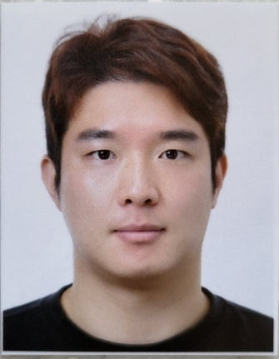
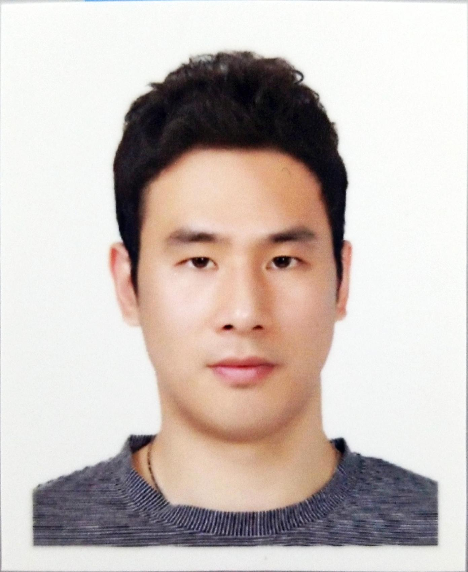
SUNGHYUN KO
KOREA
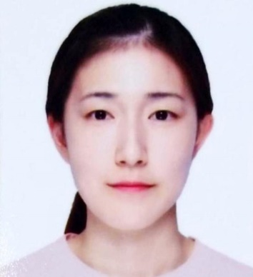

HYEWON EOM
KOREA

SARANG KIM
KOREA

GIJUNG KIM
KOREA


NAME
COUNTRY
SOOHYUN JEONG
KOREA

REN JIE GAN
MALAYSIA
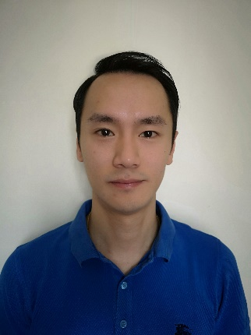

NAME
COUNTRY

